Powder Diffraction and Total Scattering Beamline P02.1

Technical Assessment Form
Please read and fill out this form carefully! The completed form should be returned to your local contact at least 4 weeks prior to your beamtime. Late or incorrect forms may mean that we cannot provide the optimal level of support for your planned experiment.
If you are unsure of any details, please consult your local contact or the beamline website.

Sketch of the Sample Position:
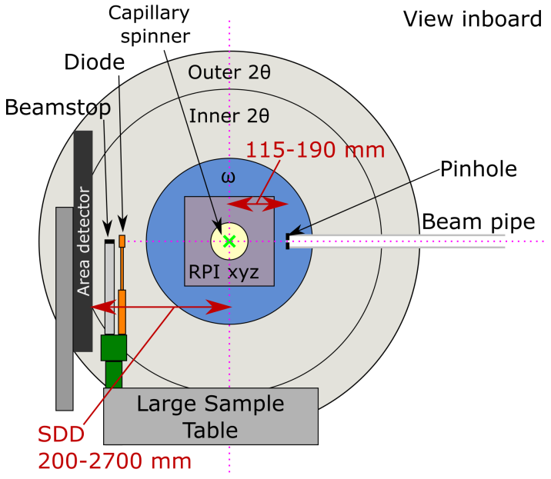
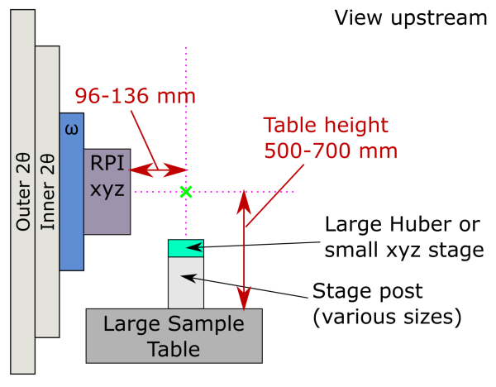
The top-plate of the large sample table has a 25 x 25 mm grid of M6 holes. For details of hole patterns on other stages, please ask your local contact.

A large selection of X-ray capillary tubes is available at the beamline. For experiments using the capillary spinner we provide holders compatible with our robotic sample changer and magnetic spinner.

Contact details of team leader:
Name:
E-Mail:
Phone:

Short Technical Description of Planned Experiment:
Please describe the key features and technical requirements of your experiment. If you wish to give further details, please add them at the end of this form.

Beam & detector parameters:
P02.1 has a fixed energy of 60 keV (λ ~ 0.207 Å). Other parameters can be selected:
Beam Size (specify in H (mm) x V (mm))
Diffraction Technique:
 | Powder Diffraction | ☐
 | Total scattering / PDF | ☐

Standard Sample Environments:
- The optimal length for capillaries for all sample environments is 20-30 mm (unless indicated)
- Users are advised to measure their own temperature calibration curve since regular, inevitable changes to the beamline set-up mean we cannot provide calibration curves for devices
- If you require an internal standard (including silicon for temperature calibration), please inform your local contact in advance of your beamtime
Capillary Spinner and Holders |  | ☐
Hot Air Blower:
 | Oxford (RT – 1200 K) | ☐
 | Mini – with sensor (RT – 973 K) | ☐
Ceramic Heater (RT – 1200 K)  N.B. No spinner; min. capillary length 33 mm. |  | ☐
Linkam Furnace/Cryostat (90 – 873 K)
 | Capillaries; N.B. No Spinner | ☐
 | Other sample form (please give details) | ☐
Cryostream:
 | 90 – 400 K (Long nozzle) | ☐
 | 90 – 500 K (Short nozzle) | ☐
Kammrath & Weiss Stress Rig (0.5 – 500 kN) |  | ☐
 | Heating option (RT – 673 K) | ☐
Splash box |  | ☐
Vacuum pump (N.B. non-corrosive gases only) |  | ☐
Thermocouple (how many?)
 | K-Type (3 –1533K)
 | R-Type (223 –2023K)

Chemistry/Preparation Laboratory:
The P02.1 chemistry lab is available for the preparation of powder samples and sample environments, as well as for (toxic or hazardous) wet chemistry.
- The chemistry lab must be booked in your DOOR registration (laboratory: PETRA III P02 47c) and you must specify all chemicals you intend to use in the lab in DOOR.
- If you wish to use any of the additional facilities in the lab, please tick the boxes in the table below as these must be booked separately. Please also indicate which facilities you wish to use in the List of apparatus… field in your DOOR registration.
- DESY is able to dispose of small amounts of liquid and solid chemical waste. N.B. If your experiment will generate significant amounts of chemical waste, please discuss this in advance with your local contact.
- Reasonable amounts of standard lab solvents are available at the beamline. These should be included in your DOOR registration.
- If sending samples to or from DESY, please consult the P02.1 Public Guides: https://confluence.desy.de/x/3QkpBw
Fumehood | ☐
Glovebox (Ar-filled) | ☐
Nabertherm Furnace (max. 1570 K) | ☐
Planetary ball milling (agate mortar and balls / only soft materials) | ☐
Ultrasonic bath | ☐
Microbalance | ☐

Lasers & Light Emitting Diodes (LEDs):
- If you wish to use a laser (above Class 1) or any LED (all LEDs are considered as Class 4) as part of your experiment this must be connected to the beamline laser interlock
Laser / LED will be used |  | ☐
 | Wavelength (in mm)
 | Output power (in mW)
 | Laser Class (if applicable)

Custom-made Sample Environment Provided by Users:
If you are bringing your own sample environment, please provide a sketch or images, indicating its dimensions and how you plan to attach it to the sample stages/table at the beamline. If you require media (e.g. compressed air, gases, water cooling, electricity), please indicate the connection and their type and specify what media you require in Section 9. Please use Section 10 (Further Information) if you need more space.
If you already have a safety concept, please submit it with this form (in case of high pressures, temperatures or electric fields; all gas experiments regardless of pressure require a safety concept). Safety concepts must also be submitted in DOOR before the start of the experiment).

Media:

Gases
- To use gases in their experiment, users must complete the Gases training in DOOR.
- Please give exact details of how gases will be used in your experiment in Section 10 (Further Information).
- Users are expected to bring all hoses and pipes needed to connect their own sample environments to the beamline supplies. Please ensure your sample environment can be connected to either 1/8 inch Swagelok fittings or 6 mm Festo Push-In fittings.
- If you require a gas with a specific purity level, please indicate this in the Other Gas field in the table.
- The maximum gas pressure available is limited by the regulators available at the beamline. Please contact your local contact for details.
 | Required for experiment? | Bottle Size or Approx. Volume Required | Required Pressure at Sample Environment | Monitoring Required?  (Staff Reference)
Compressed air  (House supply, max. 6 bar) | ☐ |  |  | No
N₂ (House supply, max. 0.5 bar) | ☐ |  |  | No
N₂ (Bottle) | ☐ |  |  | No
He | ☐ |  |  | No
Ne | ☐ |  |  | No
Ar | ☐ |  |  | No
H₂ | ☐ |  |  | Yes
O₂ | ☐ |  |  | No
CO | ☐ |  |  | Yes
CO₂ | ☐ |  |  | No
NH₃ | ☐ |  |  | Yes
Other Gas(es) – Please Specify:

Cryogens
- To use cryogens, including with the cryostream/cryostat, users must successfully complete the Liquid Nitrogen or Liquid Helium training in DOOR.
- It is only necessary to indicate the amount of cryogens needed for user supplied sample environments. For beamline operated cryostream/cryostat, your local contact will order the appropriate amount of cryogen for the length of your experiment.
 | Required for experiment? | Approx. Amount Required / litres
N2 (Liquid)  (100 l dewar) | ☐
He (Liquid)  (100 l dewar | ☐

Other Media
 | Required for experiment? | Details: e.g. voltage, flow rate etc.
Cooling water | ☐
Electricity (current & voltage) | ☐
Other: please specify

Further Information
Please provide any further relevant details about the experiment here:

